**Simplilearn Phase-5 (Ritik)**

**BLOG APP SCREENSHOTS**

1. **File Structure**

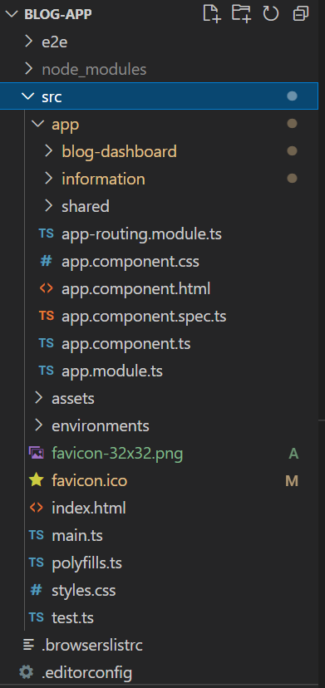

1. **Flow**

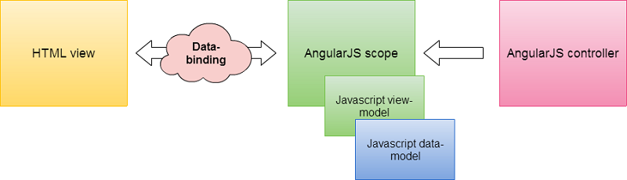

1. **Interface**

1. **Creating New Blog**

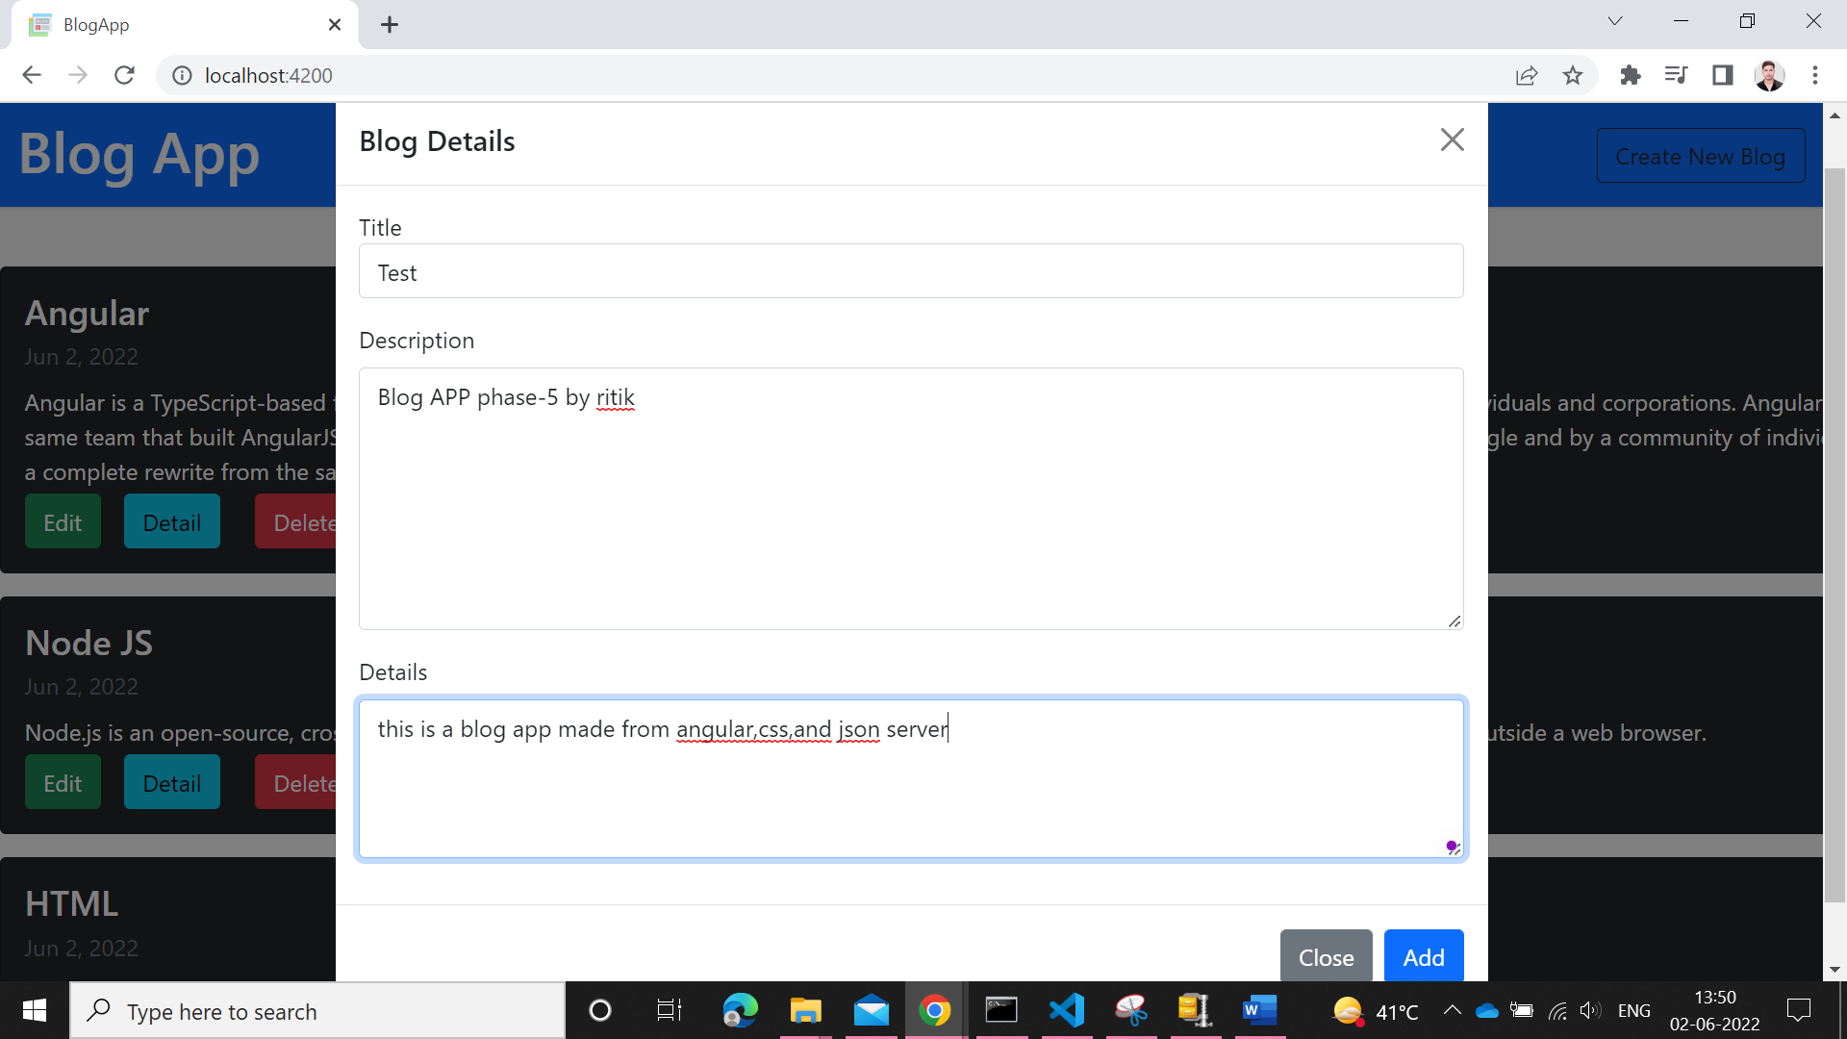

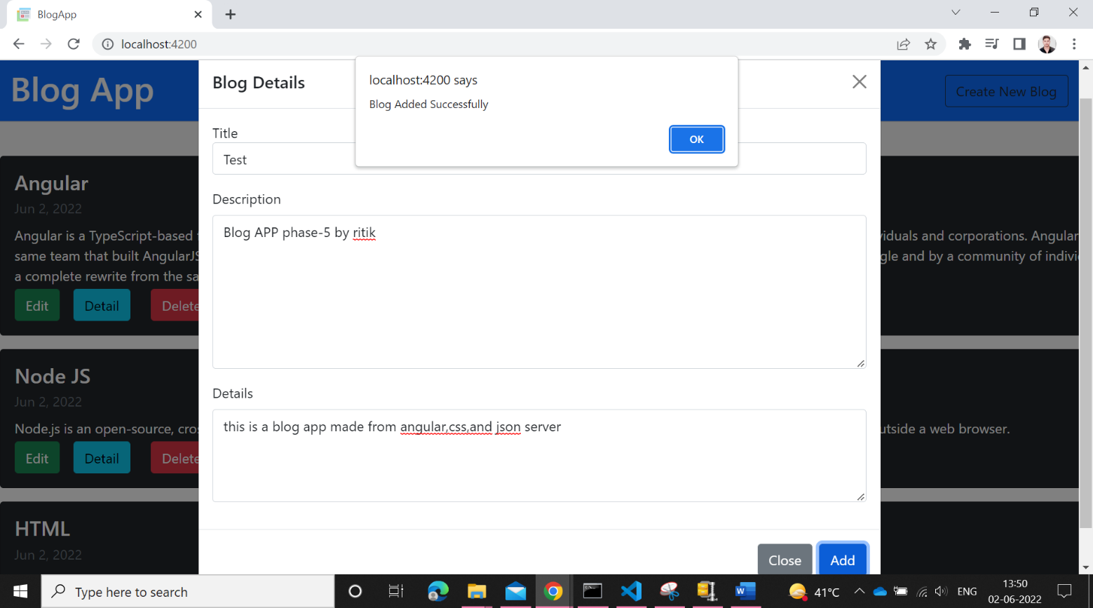

**5- Blog Details**

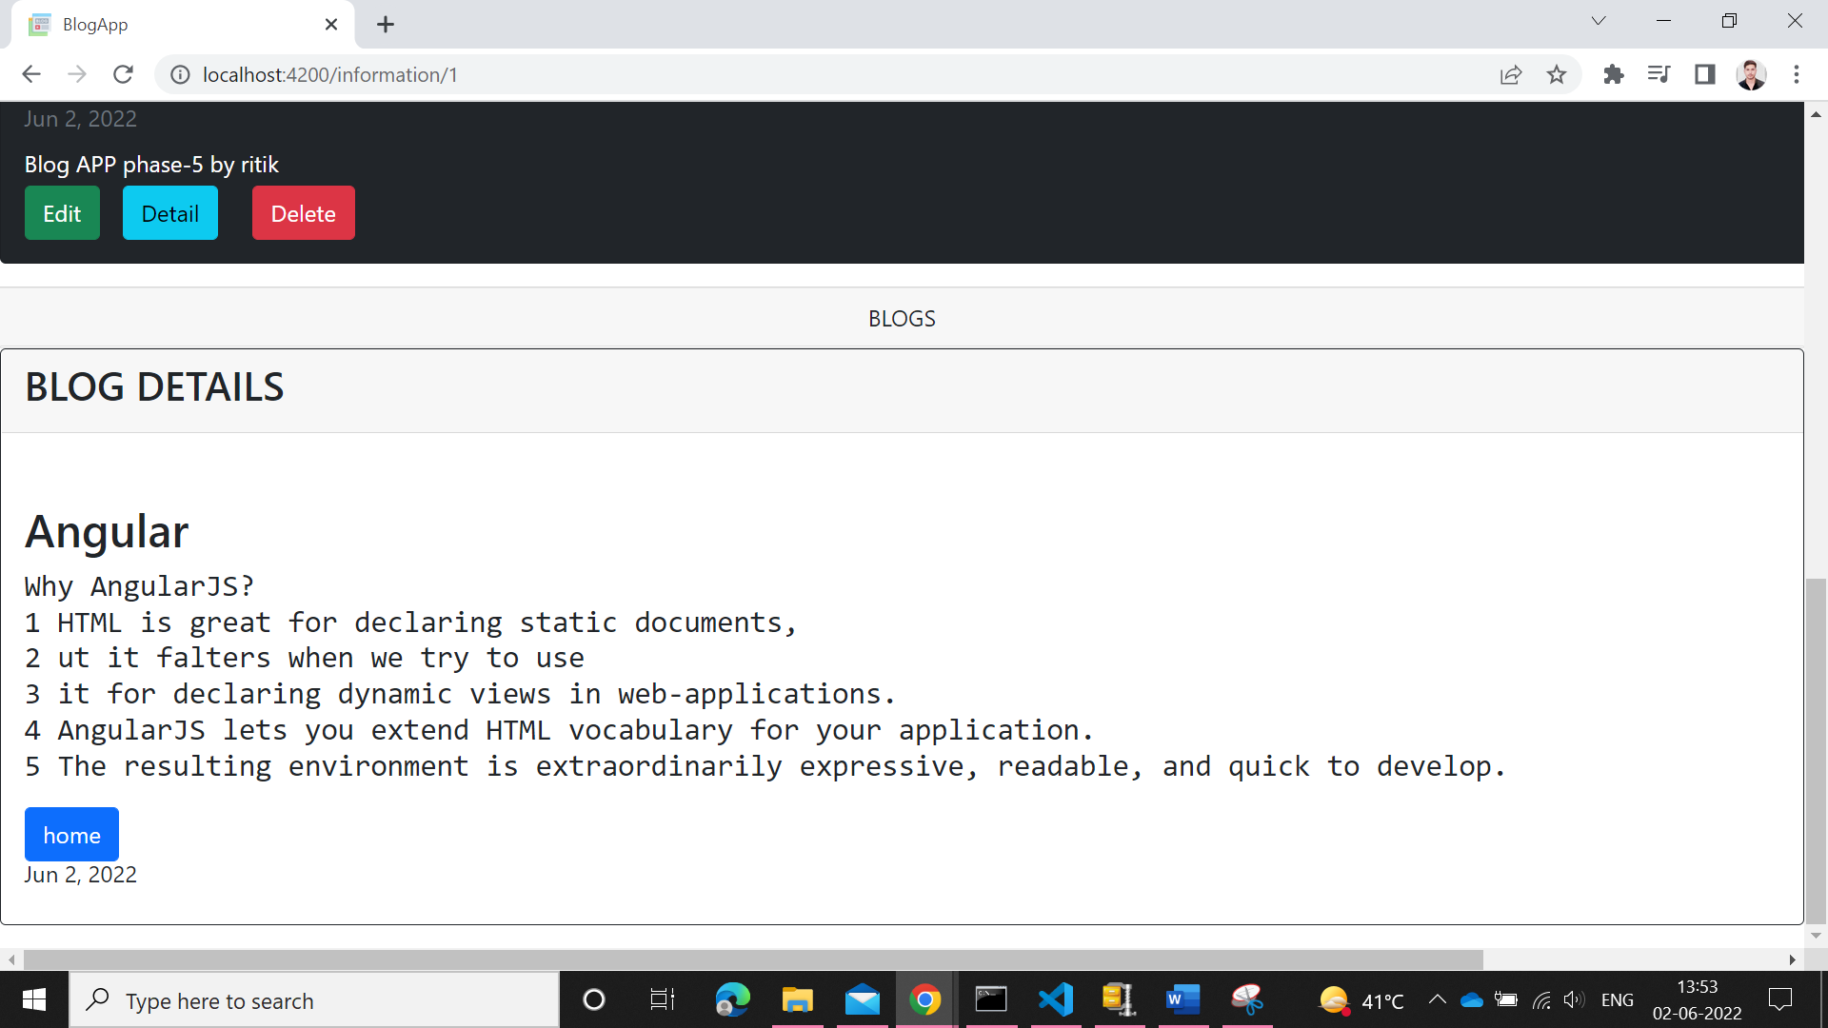

**6- Deleting Blog**

